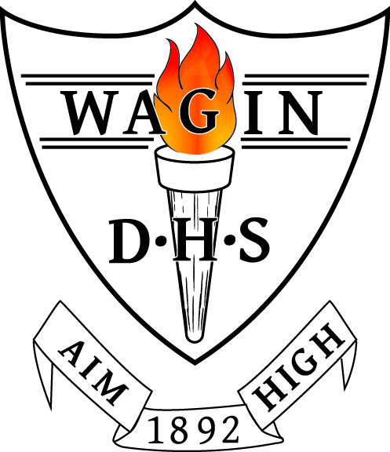
WAGIN DISTRICT HIGH SCHOOL
TERM 1, 2026 OUTLINE
Year 4/5 - Room 22

welcome to year FOUR & FIVE
I wish to extend a very warm welcome to our Year 4 and 5 students, their parents and carers. I hope that the summer holiday break was a relaxing and enjoyable one for you, and that you are feeling refreshed and ready for the 2026 school year. I look forward to working collaboratively with you to provide the best possible teaching and learning opportunities for your child. If at any time you feel the need to contact me with questions or queries, please email me at Nicole.Ward@education.wa.edu.au.
This document outlines the teaching, learning and assessments that I intend to cover in class this term. In addition to these programs, this term will also include swimming lessons, our school swimming carnival and interschool swimming carnival, Woolorama (a School Development Day), NAPLAN (Year 5 students only), a hockey clinic and an assembly.

I will be teaching Monday – Thursday each week and Ben Myers will be working in the classroom on Fridays. Grace Adams will be in our classroom throughout the week as our education assistant.
learning area outlines
ENGLISH
Reading
Paired fluency reads, picture book analysis and novel study will be three main methods used to develop student reading. Fluency reads occur four times per week, with students working in pairs to read the same passage aloud across the course of the week. Analysing picture books and a class novel will provide students with the opportunity to be exposed to vocabulary, develop their comprehension and enhance their literacy knowledge. Lit Pro will be used to track student progress with reading. Nessy will be used by some students to support them to develop their reading and spelling.
Spelling, including Grammar & Punctuation
Using Sound Waves, students are pre-tested on a set of focus words with a common sound, spend several sessions engaging in activities to learn their words and are then post tested every Friday to monitor their spelling progress. Sound Waves is also used to develop word recognition.
Writing
Sentence building will be the focus to commence our writing program this year. Students will then continue to develop their sentence structures through units on persuasive and narrative writing. Written assessment pieces for each genre will be completed at the conclusion of each unit of work. The CHIMPS (Capitals, Handwriting, Identification, Meaning, Punctuation and Spelling) editing strategy will be used to develop student reflection on their writing.
Speaking and Listening
Oral presentations of persuasive writing pieces will provide students with the opportunity to practise their speaking and listening skills in front of their peers.

MATHS
Maths sessions consist of a warm-up, mental maths using the New Wave Mental Maths resource, explicit teaching of a concept and then the opportunity for students to rotate through various tasks to practise the skill. At the conclusion of rotations, all groups reconnect to discuss the achievement of objectives.
Topics we will focus on this term include:

Year 4 – four and five digit numbers, ones and zeros multiplication facts, addition and subtraction strategies, formal addition algorithm, analogue and digital time, am and pm notation, time measurement, fours and eights multiplication facts, word problems, relationship between multiplication and division, surveys, column and picture graphs.

Year 5 – six digit numbers, place value, multiplication strategies for two, three and four digit numbers, addition and subtraction strategies, formal algorithms for addition and subtraction, decimal and common fractions, tenths and hundredths, elapsed time, multiplication patterns, word problems, column graphs and dot plots.

Written Maths assessments will occur at the conclusion of each unit of work. Mathletics and Times Tables Rockstars will be used to support learning and results will be tracked to monitor progress. Mental Maths tests occur every Friday so please check in with your child to discuss their results.

HASS
In Civics and Citizenship this term, students will learn about Australia’s democracy and the roles and responsibilities of electors and representatives in our democratic system. They will explore key features of the electoral process. In addition, students will explore the key roles of law enforcement personnel and how regulations and laws affect the lives of everyday citizens. Written assessments, including a multiple-choice assessment and a persuasive writing task, will be used to assess student understanding.

HEALTH
Our Health program will initially focus on protective behaviours. Protective behaviour education in schools is a program designed to teach students how to identify and avoid potentially unsafe situations. It focusses on developing life skills such as empowerment, communication, self-esteem, resilience and social skills to promote safety and wellbeing. The health program will also heavily focus on The Resilience Project (TRP). This is a whole school wellbeing program which teaches and supports positive mental health in the classroom and beyond. Students will use TRP diaries and journals throughout the course of the year. The Friendly Schools Plus program will be used to enhance the social and emotional learning of students.

PHYSICAL EDUCATION – Mr Myers
Students will follow the Kiddo Program to further develop and consolidate their fundamental movement skills. Students will begin to develop their skills by demonstrating adjustment of force and speed to improve accuracy and control. Students will then be linking fundamental movement skills to specific skills used in organised games, sports and activities, such as linking throwing to basketball passing and shooting. All students must be wearing sport shoes and bring a hat and water bottle to physical education classes.

SCIENCE (Biological Sciences) – Mrs Pieterse
In this unit students will examine and understand that living things have structural features and adaptations that help them to survive in their environment. They will analyse how the form of living things enable them to function in their environments, and understand that plants and animals have internal and external structures that function to support survival, growth, behaviour and reproduction. During Science lessons students are required to wear closed shoes for safety.

DIGITAL TECHNOLOGY (decoding data) – Mrs Pieterse
In the Decoding Data unit, students explore how computers represent and process information using binary code. Through hands-on activities, they investigate on/off states, convert numbers into binary and encode images. Students examine ASCII code, decoding and creating coded messages to understand how digital systems store text. In the computer lab students are required to wear closed shoes for safety.

DESIGN AND TECHNOLOGY & STEM
Together with conducting STEM challenges in teams, students will examine the role of people in design and technology occupations. They will look at the ways products, services and environments are designed to meet community needs. Students will be assessed with a written report and teamwork observations during challenges.

LOTE and The Arts are taught by specialist teachers. Please see their term outline for further information regarding the content and assessment pieces they will conduct this term.

ADDITIONAL INFORMATION
HOME READING
Students are strongly encouraged to read each night for home reading. Please sign the diary to indicate that your child has completed their reading. Students will also practise their spelling during the course of the week with a Look, Say, Cover, Write, Check task.
BOOKLIST ITEMS
Thankyou for supplying the items listed on the booklist. Spare items are being stored in the classroom for students to access as they need. If you have had difficulty sourcing items, please let me know.
ARRIVAL AT SCHOOL AFTER 8:35am
Please support your child to arrive at school after 8:35am each school day. This ensures that we are able to provide sufficient duty of care for your child.
BUCKET HATS
All students should have a bucket hat to wear each day.
INTERSCHOOL SWIMMING CARNIVAL
This will be the first year that the Year 4 students have the opportunity to be selected in the Interschool Swimming Carnival, to be hosted by Boyup Brook District High School in Week 8.
HEAT POLICY
As well as wearing a bucket hut, we strongly encourage students to wear sunscreen to school each day. This is especially relevant during our exceptionally warm days.
SWIMMING LESSONS
We will be walking to and from the town pool each day over the next two weeks. Please ensure your child brings their bathers, towel, hat, sunscreen and extra snacks.

Nicole Ward
Year 4/5

