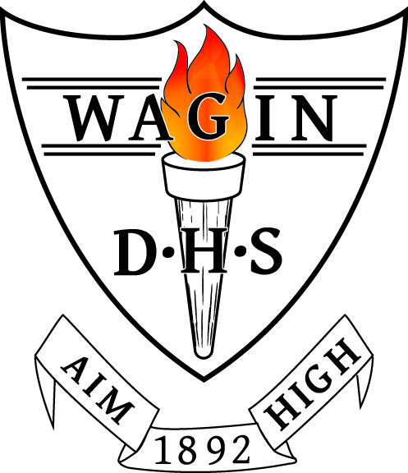
WAGIN DISTRICT HIGH SCHOOL
TERM 2, 2026 OUTLINE
Year 4/5 - Room 22

welcomE BACK
A warm welcome is extended as we return from our Easter and Term One school holiday break. I hope you had a lovely time with your family and that students are well rested and ready for Term Two. Ben Myers continues to work with me on Friday’s this term, which provides great continuity for our students. Grace Adams will continue to provide support in our room across the week.
As always, please know that I strongly believe working with you best supports your child to be set up for success at school. Please contact me at Nicole.Ward@education.wa.edu.au or 98613 200 if needed.
learning area outlines
ENGLISH
Reading
Paired fluency reads, picture book analysis and novel study will continue to be the three main methods used to develop student reading. Fluency reads occur four times per week, with students working in pairs to read the same passage aloud across the course of the week. Analysing picture books and a class novel will provide students with the opportunity to be exposed to vocabulary, develop their comprehension and enhance their literacy knowledge. Lit Pro will continue to be used to track student progress with their reading. Nessy will be used by some students to support them to develop their reading and spelling. Some students will also participate in the MacqLit intervention program and the Small Group Tuition program.
Spelling, including Grammar & Punctuation
Using Sound Waves, students are pre-tested on a set of focus words with a common sound, spend several sessions engaging in activities to learn their words and are then post tested every Thursday to monitor their spelling progress. Sound Waves is also used to develop word recognition.
Writing
Students will continue to develop their sentence structure this term, and will apply this knowledge through units on persuasive, informative and poetry writing. Written assessment pieces for each genre will be completed at the conclusion of each unit of work. The CHIMPS (Capitals, Handwriting, Identification, Meaning, Punctuation and Spelling) editing strategy will be used to develop student reflection on their writing.
Speaking and Listening
Oral presentations of persuasive writing pieces will provide students with the opportunity to practise their speaking and listening skills in front of their peers.

MATHS
Maths sessions consist of a warm-up, mental maths using the New Wave Mental Maths resource, explicit teaching of a concept and then the opportunity for students to rotate through various tasks to practise the skill. At the conclusion of rotations, all groups reconnect to discuss the achievement of objectives.
Topics we will focus on this term include:
Year 4 – written subtraction of two and three digit numbers, informal and formal algorithms for subtraction, reading scales and comparing mass, equivalent fractions, converting centimetres to millimetres, perimeter of regular polygons, temperature on a scale, formal addition algorithm, joining and splitting 2D shapes, transformations and tessellations.
Year 5 – formal multiplication algorithm, gross and net mass, constructing and interpreting dot plots, tonnes, factors and multiples, estimating total cost of purchases, mental strategies to add and subtract, creating a financial plan, angles in shapes, categories of triangles and quadrilaterals, regular polygons.
Written Maths assessments will occur at the conclusion of each unit of work. Mathletics and Times Tables Rockstars will be used to support learning and practicing new concepts, these results will be tracked to monitor progress. Mental Maths tests occur every Friday so please check in with your child to discuss their results.

HASS - Geography
We will explore the factors that shape the environmental characteristics of places. We will examine the way people alter the environmental characteristics of Australian places. The impact of bushfires and floods on communities will also be an area of focus. Students will be assessed with an information report and a persuasive argument.

HEALTH
We will continue using The Resilience Project to enhance the social and emotional learning of students. Student journals and diaries will be used as we explore gratitude, empathy, mindfulness and emotional literacy. We will also continue to learn about protective behaviours this term. The program will include personal behaviours and strategies to remain safe in uncomfortable or unsafe situations, such as being alert and aware or unsafe situations and using assertive behaviour and language. Students will be assessed through creation of a poster and various written tasks.

PHYSICAL EDUCATION – Mr Ben Myers
In Term 2 students continue with the Kiddo Program to further develop and consolidate their fundamental movement skills. Students will begin to develop their skills by demonstrating adjustment of force and speed to improve accuracy and control. With Cross Country taking place later this term, students will also begin larger invasion games and relays to further develop their endurance. All students must be wearing enclosed shoes and bring a hat and water bottle to physical education classes.

DESIGN AND TECHNOLOGY – Food & Fibre Production
Food and fibre production will be the focus area of our Design and Technology unit this term. Students will investigate types of technologies used in food and fibre production processing, including how they are used to help meet consumer needs. Assessments will include a report and written tasks.

DIGITAL TECHNOLOGIES – Mrs Vanessa Pieterse
In this 11-week unit, students will learn the fundamentals of game design and development using Scratch 3 or Microsoft MakeCode Arcade to create an entry for the Australian STEM Video Game Challenge (STEM VGC). Through a series of lessons and activities, students will work across the curriculum developing their critical thinking, problem-solving, and digital literacy skills. The unit will culminate in the creation and submission of a fully developed video game prototype aligned with the competition's Game Design Document (GDD) and scoring rubrics. In the computer lab students are required to wear closed shoes for safety.

SCIENCE – Mrs Vanessa Pieterse
Earth and Space Sciences: Sudden and Extreme Changes to Earth’s Surface
In this unit, students investigate major geological and extreme weather-related events such as earthquakes, volcanic eruptions, tsunamis, drought, bushfires, floods and cyclones. Through questioning, gathering evidence and developing explanations, they understand how rapid or extreme natural events can affect the Earth’s surface and environment. Students learn about the impact that natural hazards can have on the First Nations Peoples of Australia’s cultural heritage and ways that this can be reduced. They research and investigate scientific and technological developments in measuring, predicting and minimising the effects of natural hazards, and will plan and produce an early warning system for an at-risk community. In the Science class students are required to wear closed shoes for safety.

LOTE (Noongar) – Ms Emmaline Winmar
This term we are continuing with the topic of health and hygiene and we will then move on to animal tracks. This subject introduces students to the fundamentals of Noongar communication through speaking, listening, reading, and writing. Students will learn to express basic ideas in familiar contexts, develop cross-cultural awareness, and build confidence in language learning.

VISUAL ART – Mrs Jane Neil – Smith
This term in Art students will be exploring a variety of art mediums and techniques, expanding on skills taught previously. Students will create 3D and 2D art pieces with a focus on Medieval Art, mythology and fantasy, creating developmental drawings to encourage thinking and problem solving. Some of the techniques that will be taught include textiles, printmaking and basic painting skills.

ADDITIONAL INFORMATION
OUR ASSEMBLY
We will be performing at an assembly on Friday 15th May. We are dancing to a fun, upbeat song so students are asked to wear free dress on this day – whatever they feel most comfortable dancing in!
SEMESTER ONE REPORTS
At the end of this term you will receive your child’s Semester One report. This will give you a good indication of how your child is progressing this year. If at any point this term you would like to touch base regarding progress, please don’t hesitate to contact me.

Nicole Ward Year 4/5 Nicole.Ward@education.wa.edu.au

