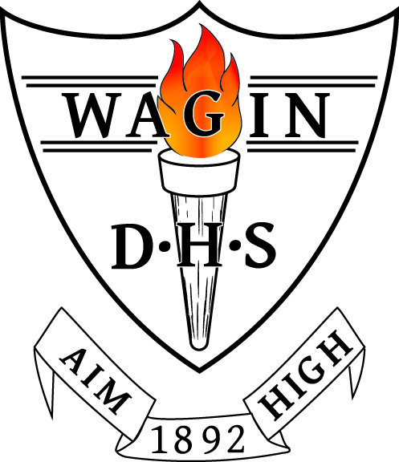
WAGIN DISTRICT HIGH SCHOOL
TERM 3, 2026 OUTLINE
Year 5/6 - Room 21

welcomE BACK

Welcome to Term 3! I am excited to be teaching the Year 5/6 class this term. We have a busy and productive term ahead, with many opportunities for learning both inside and outside the classroom.

One of the highlights of the term will be the Year 6 Camp to Woodman Point and Perth. While the Year 6 students are away, the Year 5 students will join Mrs Kilpatrick and the Year 4/5 class, where they will continue with their learning program and enjoy the opportunity to work alongside another class.

Our class will proudly present the school Assembly in Week 5, and students will also have the opportunity to represent the school at the Netball and Hockey Carnivals later in the term. On Fridays, students will join Mr Myers and the Year 4/5 class for our weekly sport program, providing opportunities to develop teamwork, skills, and sportsmanship.

This outline provides an overview of the learning experiences planned for Term 3. I look forward to working with your child and celebrating their learning and achievements throughout the term.

learning area outlines

ENGLISH
This term, students have begun exploring the picture book The Watertower by Gary Crew. Through this engaging text, they are analysing character, plot, vocabulary, and the author's use of imagery to deepen their understanding of literary techniques. Students have also commenced a narrative writing unit, with a focus on text structure, planning, drafting, editing, and publishing. Their completed narratives will be formally assessed once final copies have been published. Following camp, students will study Beneath the Surface, the sequel to The Watertower, before moving into a novel study on the book Holes by Louis Sachar, providing further opportunities to develop comprehension, discussion, and analytical skills. Later in the term, the writing focus will shift to the report genre, with students producing informative texts linked to their Geography studies. The Sound Waves spelling program will continue as usual, with pre-tests conducted each Monday and post-tests each Friday. Students are expected to practise their weekly spelling words at home to support their learning and achievement.

MATHS
This term, students will continue to develop their mathematical knowledge and skills through a balanced program that promotes fluency, reasoning, and problem-solving. Daily lessons will include New Wave Mental Maths and Daily Review to reinforce key concepts, build confidence, and strengthen number fluency. Students will begin the Semester 2 ORIGO mathematics program, exploring new concepts through explicit teaching, hands-on activities, and collaborative learning experiences. Real-life problem-solving tasks and mathematical investigations will provide opportunities for students to apply their understanding in meaningful contexts and develop critical thinking skills. Students will also continue to have access to Mathletics as a supplement to the core mathematics program. This online platform supports the review and consolidation of classroom learning while providing extension opportunities for students who are ready for additional challenge.

include New Wave Mental Maths and Daily Review to reinforce key concepts, build confidence, and strengthen number fluency. Students will begin the Semester 2 ORIGO mathematics program, exploring new concepts through explicit teaching, hands-on activities, and collaborative learning experiences. Real-life problem-solving tasks and mathematical investigations will provide opportunities for students to apply their understanding in meaningful contexts and develop critical thinking skills. Students will also continue to have access to Mathletics as a supplement to the core mathematics program. This online platform supports the review and consolidation of classroom learning while providing extension opportunities for students who are ready for additional challenge.

HUMANITIES AND SOCIAL SCIENCES (HASS)
This term, our HASS focus is Geography. While all students will participate in shared learning experiences, they will complete year-level research tasks and an informative report aligned with their specific curriculum focus. The Year 5 focus is on the countries of Asia and Year 6 will investigate North and South America. Throughout the term, students will develop their geographical knowledge and skills through the study of mapping, topography, climate, environments, population, natural and human features, and the ways people interact with places. Students will also strengthen their research, inquiry, and presentation skills as they investigate the unique characteristics of different regions.

HEALTH
This term, students will continue to participate in The Resilience Project, developing positive mental health and wellbeing through a focus on gratitude, empathy, mindfulness, and emotional resilience. Students will also participate in the Growth and Development program, delivered by School Nurse Sasha Biggs in conjunction with the Year 4/5 class. These sessions will provide age-appropriate information to support students' understanding of physical, emotional, and social changes, while encouraging respectful relationships and healthy decision-making.

PHYSICAL EDUCATION – Mr Ben Myers
In Term 3 students continue to develop and consolidate their fundamental movement skills by demonstrating adjustment of force and speed to improve accuracy and control. This will be tailored to track and field athletics events in preparation for their Faction Athletics Carnival which will be held in the first week of Term 4. Students will also practise their Faction Team Games including Leaderball, Tunnel Ball and Passball. All students must be wearing enclosed shoes and bring a hat and water bottle to physical education classes.

DESIGN AND TECHNOLOGY
This term, students will engage in a range of hands-on design and technologies learning experiences that encourage creativity, collaboration, and problem-solving. Students will apply the design process as they plan, create, test, and evaluate a standing human structure using straws and wire, considering strength, stability, and functionality. In conjunction with their Science program with Mrs Ahmed, students will also design, build, and test solar-powered cars, exploring how design choices influence performance while developing an understanding of sustainable technologies and engineering principles.

DIGITAL TECHNOLOGIES – How Artificial Intelligence Makes Decisions
Mrs Pieterse will teach DigiTech. This module is named to highlight its focus on unravelling the processes that AI systems use to analyse training data and make decisions. AI concepts are broken down into engaging, age-appropriate lessons that focus on the critical role of data. Students will use Code.org’s AI tools for fun, educational AI experiences while gaining insight into how AI works behind the scenes. Each lesson provides several opportunities for class discussions about AI, bias, and the impact of AI tools on daily life. For safety closed shoes are required in the Computer Lab.

SCIENCE – Physical Sciences
Mrs Ahmed will teach Science two lessons per week. In Term 3, students will investigate the transfer and transformation of energy in simple electrical circuits. They will explore how electrical energy can be transferred through a circuit and transformed into other forms of energy, such as light, sound, heat and movement. Students will examine the function of circuit components, including batteries, wires, switches, globes and motors, and investigate the role of conductors and insulators in allowing or preventing the flow of electricity. Through hands-on investigations, students will make predictions, identify variables to ensure fair tests, collect and record observations, and communicate their findings using scientific language and representations such as labelled diagrams. For safety, closed shoes are required in science.

LOTE (Noongar) – Ms Emmaline Winmar
This term we are learning about Maambakoort Barna (Ocean Animals). This subject introduces students to the fundamentals of Noongar communication through speaking, listening, reading, and writing. Students will learn to express basic ideas in familiar contexts, develop cross-cultural awareness, and build confidence in language learning.

ART – Mrs Jane Neil-Smith
This term in Art students will continue to explore a range of art mediums and techniques, expanding on prior experiences and introducing new skills and processes. The year 5/6 group only have one single session per week, so the activities are selected to be quick and easily completed. Later in the term the whole school will be involved in contributing to a Halloween display for a community-based celebration and art works will be created for this purpose.

ASSESSMENT
Throughout the term, students will have opportunities to demonstrate their learning through a variety of assessment tasks across the curriculum. These include:
- Mathematics: Each teaching module will be followed by a test to review student understanding of the concepts covered. (3 per term)
- English – Reading Comprehension and Literary Analysis
Students will complete a comprehension and response task based on The Watertower and Beneath the Surface, demonstrating their understanding of character, plot, themes, vocabulary, and imagery.
- English – Narrative Writing
Students will plan, draft, edit, and publish a narrative. The final published piece will be assessed using the Year 5/6 writing criteria, with a focus on structure, language features, and editing.
- HASS (Geography): Students will research their allocated geographical region (Asia for Year 5 or North and South America for Year 6) and produce an informative report demonstrating geographical knowledge, research skills, and appropriate use of maps and geographical terminology.
- Technologies: A design challenge where students will plan, create, test, and evaluate a design solution.
- Health: Participation in TRP classroom activities, self-reflection and a summative task related to the Growth and Development program.
Assessment is ongoing throughout the term and is used to monitor student progress, celebrate achievement, and guide future teaching and learning.

ADDITIONAL INFORMATION

Thank you for your continued support throughout the term. Working together helps to create the best possible learning environment for your child.

If you have any questions or concerns, or would like to discuss your child's progress, please don't hesitate to contact me via email at grace.adams@education.wa.edu.au.

Grace Adams

